**Project Design Phase-II**

**Data Flow Diagram & User Stories**

|  |  |
| --- | --- |
| Date | 14 July 2025 |
| Team ID |  |
| Project Name |  |
| Maximum Marks | 4 Marks |

**Data Flow Diagrams:**

A Data Flow Diagram (DFD) is a traditional visual representation of the information flows within a system. A neat and clear DFD can depict the right amount of the system requirement graphically. It shows how data enters and leaves the system, what changes the information, and where data is stored.



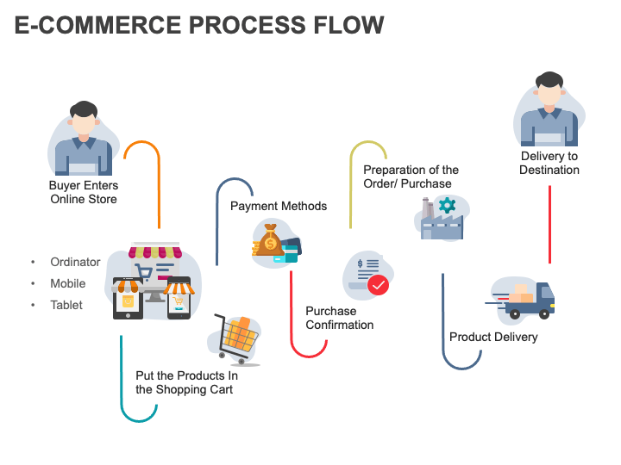

**User Stories**:

| **User Type** | **Functional Requirement (Epic)** | **User Story Number** | **User Story / Task** | **Acceptance criteria** | **Priority** | **Release** |
| --- | --- | --- | --- | --- | --- | --- |
| Customer (Mobile user) | Registration | USN-1 | As a user, I can register for the application by entering my email, password, and confirming my password. | I can access my account / dashboard | High | Sprint-1 |
|  |  | USN-2 | As a user, I will receive confirmation email once I have registered for the application | I can receive confirmation email & click confirm | High | Sprint-1 |
|  |  | USN-3 | As a user, I can register for the application through Facebook | I can register & access the dashboard with Facebook Login | Low | Sprint-2 |
|  |  | USN-4 | As a user, I can register for the application through Gmail | |  | | --- | | I can register using Gmail credentials |  |  | | --- | |  | | Medium | Sprint-1 |
|  | Login | USN-5 | As a user, I can log into the application by entering email & password | |  | | --- | | I can access my dashboard after logging in |  |  | | --- | |  | | High | Sprint-1 |
|  | Dashboard | |  | | --- | | USN-6 |  |  | | --- | |  | | |  | | --- | | As a user, I can browse dishes with ratings, descriptions, and offers. |  |  | | --- | |  | |  | |  | | --- | | Medium |  |  | | --- | |  | | Sprit-1 |
| Customer (Mobile user) | |  | | --- | | Cart Management |  |  | | --- | |  | | |  | | --- | | USN-7 |  |  | | --- | |  | | |  | | --- | | As a user, I can add or remove dishes from my cart. |  |  | | --- | |  | | |  | | --- | | Cart updates in real-time |  |  | | --- | |  | | |  | | --- | | Medium |  |  | | --- | |  | | Sprit-1 |
|  | |  | | --- | | Order Placement |  |  | | --- | |  | | |  | | --- | | USN-8 |  |  | | --- | |  | | |  | | --- | | As a user, I can place an order by selecting dishes and providing address and payment method. |  |  | | --- | |  |   Dishes and providing address and payment method | |  | | --- | | I receive order confirmation with estimated delivery time |  |  | | --- | |  |   Estimated delivery time | High | Sprit-1 |
|  | |  | | --- | | Order Tracking |  |  | | --- | |  | | USN-9 | |  | | --- | | As a user, I can track the status of my food delivery. |  |  | | --- | |  |   -very | |  | | --- | | I can see real-time updates and estimated delivery time |  |  | | --- | |  |   And estimated delivery time | Medium | Sprit-2 |
| Customer  (Web user) | Search | |  | | --- | | USN-10 |  |  | | --- | |  | | As a user, I can search for restaurants or dishes via keyword or filters. | Relevant results are returned | Medium | Sprit-2 |
| Customer Care Executive | Support | USN-11 | As a support exec, I can view and respond to user complaints and issues. | Complaints are displayed and can be marked as resolved | Medium | Sprit-2 |
| Administrator | Dashboard | |  | | --- | | USN-12 |  |  | | --- | |  | | As an admin, I can view user data, orders, and restaurant activity in a dashboard. | I can monitor and manage all data from a centralized admin panel | High | Sprit-2 |